National Association of Retired & Veteran Railway Employees, Inc.

NARVRE National Office 509 W Reed St • Moberly, MO 65270 Phone: 660/269-8895 • Fax: 660/269-8896 • Toll Free: 1-800-551-2588

Email: [NARVRE@gmail.com](mailto:NARVRE@gmail.com) • WEBSITE: [www.narvre.info](http://www.narvre.info) Published ten times a yean Cost - Membership in a Unit or Membership-at-Large

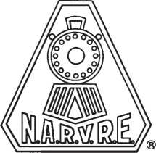

- SINCE 1937 -

NARVRE NEWSLETTER

OCTOBER 2015

VOL. 29 NO. 09

FROM THE

NATIONAL PRESIDENT —

A

s I write this column we are only nine months away from the National Convention to be held in St. Louis, Missouri May 15th, 16th and 17th, 2016. The convention will be held at the St Louis Union Station Hilton Inn.

The Host unit is Unit 56 of St. Louis headed up by President Norbert Shacklette who can be reached at (636) 451-2890 if you have any questions regarding the convention. We are at the time of the year when Unit elections are taking place. When electing a delegate or alternate to the convention try and see if they are absolutely going to attend. It helps the Convention Committee and the National Secretary's office to keep track of the dele­gate count. It also helps with the rooms the Host Committee has to reserve as they are

From the National Legislative Director —

T

he summer recess is over and Con­gress has returned to work following the Labor Day Holiday. They have an abundance of unfinished business in front of them, as this 114th Congress has not passed a single Appropriation bill. The fiscal year ends on September 30th, leaving them three short weeks before they bump up against another threat of a government shut-down which could happen on October 1. In addition to finding the compromise needed to pass funding bills for all federal agencies, they will also risk another financial default on the nation's debt if they cannot come to grips with an agreement to raise the federal debt ceiling, which expires October 30. While assuming they cannot, or will not reach consensus, Congress will undoubtedly be forced to agree on another stop-gap funding bill, or Continuing Res­olution (CR). The latest talk on Capitol Hill has the House leadership considering responsible for the head count.

I have been notified that national Secretary Treasurer Joyce Burton will not be seeking reelection at the convention. The NST posi­tion is the most important position with work efforts alone. Whoever is elected the new NST, the office will be moved to the home area of that person. All serious interested parties should contact Joyce and she can fill you in on the duties and responsibilities of the office. If we have a serious candi­date^) arrangements can be made to visit the office at NARVRE expense to view the operation to see if it fits your point of view. Joyce can be reached at 1-800-551-2588.

Convention Resolutions must be in the NST office seventy-five days before the start which is March 2, 2016. The reason for this is so when preparing the booklets for the delegates they have a copy of the

a year-long CR, to cover all aspects of the federal budget. While CR's are now consid­ered normal business, a year-long patch is frowned upon by the accounting agencies, citing numerous administrative problems, to include causing more delays in hiring for projects at the state level. That said, the two parties are indicating support to kick this can for another 12 months, due to the 2016 election campaigns kicking into high gear.

Transportation offices in both cities and states, have collectively been lobbying Con­gress as the lack of a signed transportation bill is delaying highway and rail projects and postponing the hiring of workers that should have been on jobs in the early summer months. Federal funds for highway and tran­sit work expired at the end of June, and the House forced an agreement for a five-month funding extension. While the Senate passed a six-year bipartisan transportation bill, they were also coerced into signing onto the tem­porary funding bill passed in the House. That bill is a $8 billion extension to the Highway Trust Fund (HTF) to cover payments to the

Resolutions. Keep in mind every little bit helps the national office in getting ready for the convention. It is a lot of work and effort by a few people to put on a good run convention.

Finally, I want to comment on NARVRE- PAC our Political Action Committee. This is only a Federal Pac and can not to be used for state candidates such as governors, state legislators or local officials. NARVREPAC is strictly voluntary with no Unit dues or national dues to be spent on behalf of Federal candidates. We seek individual donations from members on a voluntary basis to support candidates friendly to retirees in general. All contributions should be sent to the NST's office with the check made out to NARVREPAC. We thank you for consideration of this request. —Tom Dwyer, National President

states for infrastructure on highway and rail projects through June of 2016. Over the last six years Congress has now passed 34 temporary extensions to keep federal funding flowing, while ignoring the HTF which was (and is) going broke. The six-year Senate bill would authorize $350 billion for roads, bridges, and rail infrastructure. However, the bill only pays for the first three years, so that will be a primary hurdle for Congress in trying to iron out a multi-year transportation bill that the President will sign. They also must get around certain political problems with their members regarding proposals unrelated to the issue of transportation. It's a well known practice to load up these major bills, like a "Christmas tree", and this years appropriations are no different, with amend­ments like de-funding Planned Parenthood, or re-authorizing the Export-Import Bank, whose charter was allowed to expire last June. Another provision (of course) would repeal the Affordable Care Act. None of these amendments are germane to these

continued on page 5

From the National Vice President —

W

ith only three months left of the year, much of NARVRE's work has been in the works and as we near the holidays of Thanksgiving and Christmas we hope to stay as active as possible to protect all Senior benefits including our Railroad Retirement, Social Security, Medicare, Medicaid and an Affordable Health Care. Much of the time remaining in 2015 will be spent with our families to the year's end. Given the nature of the political season many will be focusing on the regular primary congressional elections which this year include the Presidential Elections. We stood strong to guarding the essence of our NARVRE organization to promote, protect and preserve our pension benefits from being weaken or degraded. This year we made some accomplishments with positives and negatives in terms of membership. Many units shrank membership because members and officers suffer old age, death, sickness of both spouses and death; and, new officers do not step up to fill-up emerging vacancies and leadership positions; however members were not lost but moved to the at large Unit 801. But having said that, I have to say I am proud of those who stay and tackle that commitment of protecting our Railroad Retirement pension. We are ameliorating the notion that retirees did not even know there was a NARVRE organization in existence to protect their pension. We will never fully alert all retirees, but we are making improvements in that campaign through the NARVRE informational meetings, the Railroad Retirement Board Informational Meetings and use of posters in railroad bulletin boards including visiting union meetings, conventions and conferences while the railroaders are still working. The use of our promotional tactics helped to attract new members. I know how frustrating it can be when officers would like to attend meetings that may not have enough value to offset the economic cost, but considering and evaluating by case basis, most of the time we attend these areas to attract new members. Our sponsor and past President Whitey Westphal who represents NARVE's designated legal counsel of the Will Moody Law Firm is always ready and available to sponsor informational meetings without hesitation. All you have to do is call and ask.

Organizing new units is the most important task of the Area Di­rectors: After meeting all requirements, on August 15, 2015 Area 8 Director Jim Johnson presented a Charter to Unit #022 of Florence, S.C. "With 30 to 40 people present for the charter presentation, my wife Carol and myself were greeted as one of the group," said Jim Johnson. Jim had been there in February to introduce NARVRE, along with Whitey Westfall. The group was eager to hear that an organization had been in place since 1937 and that it was created by union leaders at a time that they felt a "Pension Organization" needed to be formed, whose "sole responsibility" would be to keep watch that the Railroad Retirement Pension remained secured. Many questions were asked regarding benefits. He said, "six unions, 21 men and women met in Louisville, KY, on Labor Day, 1937 to form the organization known today as The National Association of Retired and (Veteran, added later) Railway Employees Organization, Incorporated. This group in Florence S.C. was already meeting as a Maintenance of Way retirees group. This group was well organized, witnessed the day of presentation of their charter, by the way they presented motions, according to Roberts Rules of Order. With a base already organized as well as they are, they will prove to be a great asset to NARVRE. Under the Leadership of James Williams, President, I look forward to years of friendship and a strong base for the only unit, at this time, in South Carolina". (1) Photo: Area 1 Director James Johnson presenting the Charter to President James Williams. (2) Photo: New Unit 022 Florence N.C. officers: From left to right is Sam McCullom, James Williams president, James R. Johnson, R. J. Wilson, David White, and Joe Myers.

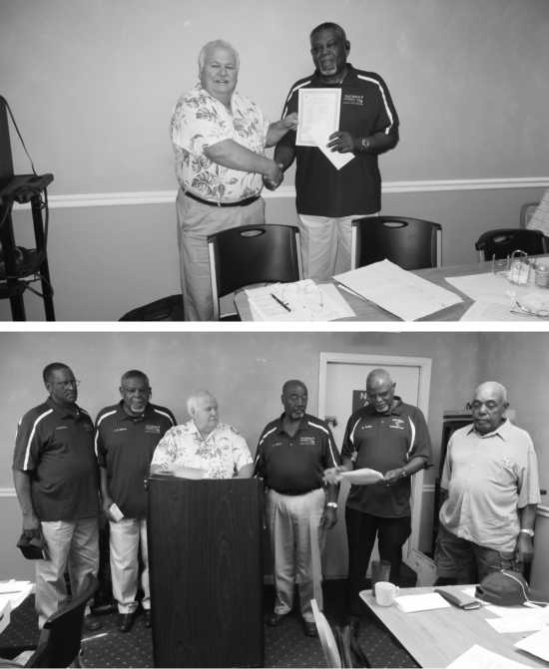

Area 5 Director G. G. Gonzalez and Legislative Representative Dennis Taylor of the Houston Unit #187 were invited to attend the 1st annual RRB informational seminar in Houston, Texas. They attended and manned a NARVRE Table at a Railroad Retirement Board informational meeting on August 28, 2015 with literature and applications. NARVRE was also allowed to place our poster in at the RRB lobby. No new members signed up but many applications were taken.

There were over 80 people registered. Special thanks to Cheryl and Doris with RRB for inviting NARVRE.

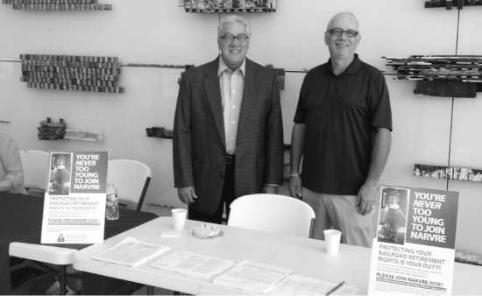

Photo: G.G. Gonzalez and Dennis Taylor Houston NARVRE informational Table.

continued on page 3

Area 4 Director Gary Nelson attended the "BNSF Family Day at Duluth" and distributed many NARVRE flyers and ap­plications. Jack Heggie Jr. BNSF Yardmaster at Superior, WI helped to promote NARVRE membership in Unit 92 at Duluth, Mn Family Day. We distributed membership forms for Unit 92 among BNSF Employees during the Family Day Celebration and Train Ride & Picnic. BNSF management also participated in the membership drive. "All railroad employees, scheduled or exempt are included in Railroad Retirement. We must all strive to protect that which is Ours!" said Gary R Nelson. (1)Photo of (L) Jack Heggie Jr. and (R) Gary Gary Nelson; (2) Gary Nelson-NARVE Informational Table

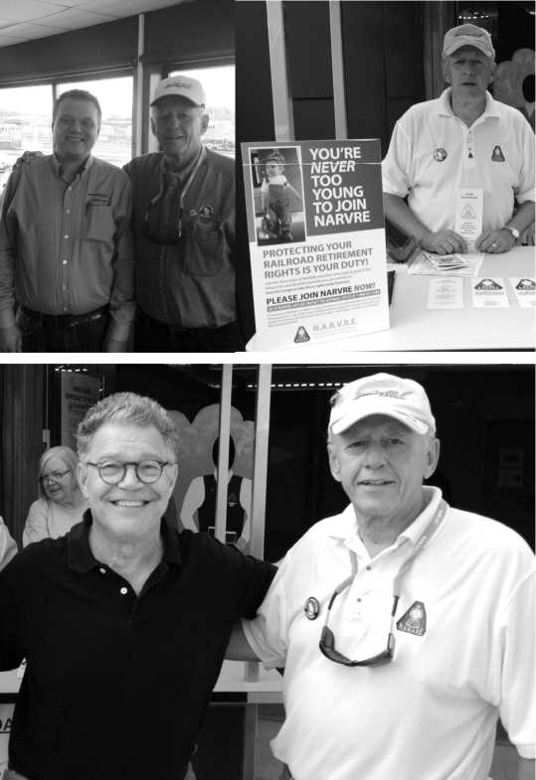

On September 2nd, 2015 Senator Al Franken visited the MN AFL-CIO Labor Pavilion at the Minnesota Fair Trade Coalition TTP event-- UTU-SMART-TD is an active member NARVRE member of Unit 109 P. J. Qaly and Gary Nelson met with him the Senator express full support for our NARVRE and Senior issues. Area 4 Director Gary Nelson pictured (3) above is with Senator Al Franken at a hazmat town hall meeting in NE Minneapolis.

Assistant Area 1 Director Philip Steward of Olive Branch MS, President Tom Dwyer and Past President Whitey Westphal, had been organizing prospective NARVE Units in the following areas and as the organizing came to fruition, informational meeting took place. Mobile Alabama - Informational Meeting August 18, 2015 1100 AM, Birmingham Alabama - Informational Meeting August 19, 2015 1100AM, Jasper, Alabama - Informational Meeting August 19, 2015 530PM, and a meeting to come in Cleveland, Mississippi - Informational Meeting September 12, 2015 1200PM. Starting with a meeting on August 18, 2015 in Mobile, AL to Jasper/Bir­mingham, AL meeting on the 19, 2015 signed up 23 new members; Proceeding to Jasper Al; Gardendale AL. 'The Mobile, AL (Jasper/ Birmingham) Meeting garnered 7 new Members includes 4 lifetime memberships. There should be additional applications arriving at the National office as a result of our visit to these locations. As a result of the informational meeting, we should be initiating new units in Jasper and Mobile before January 2016. We are hoping to initiate a Birmingham unit sometime before or after the NARVRE Convention in 2016. We should be initiating new units in Jasper and Mobile before January 2016. Birmingham we are hoping to initiate a unit probably after the 2016 convention," said Phil Steward.

Tri-fold brochures had been sent to contacts as follows: Danny McGough - 7884 Bagley Road - Dora, Al 35062 (10 copies); James Fuqua - 7151 Griffice Road - Mobile, Al 36618 (50 copies); Gerald Buzbee - 1406 North Primrose Lane - Jasper, Al 35503 (50 copies); Robert Weaver - 2063 Pinehurst Drive - Gardendale AL 35071 (25 copies)

Thanks in advance for your cooperation in this matter. Other infor­mational material had been sent to James Fuqua has identified 15 - 20 more retirees in the Mobile area who will be submitting applications for membership. This number will be more than adequate to start up new unit in Mobile. We are scheduled to make a presentation to another railroad retiree group in the area this in September. A start up meeting is set for November 20, 2015

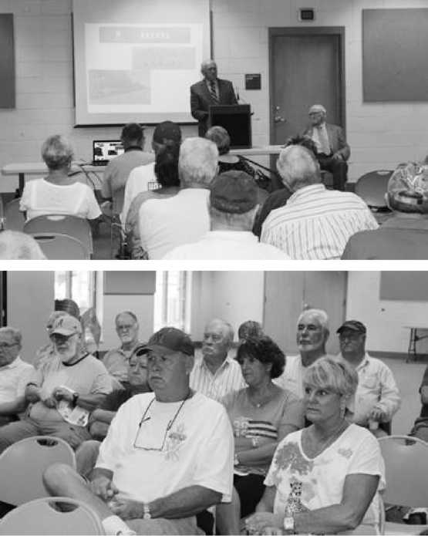

NARVRE Past President (Mtg. Sponsor) Whitey Westphal and NARVRE Ntl. President Tom Dwyer addressing Retirees in Jasper (2) Group-Pictured above Mr. & Mrs, Gerald Buzbee.

Mobile Al organizing leadership from left to right Carl Watson, Philip Steward, Al Charest, Larry Nelson, James Fuqua, Mr. & Mrs. Harold Price, C W Coleman, Whitey Westphal.

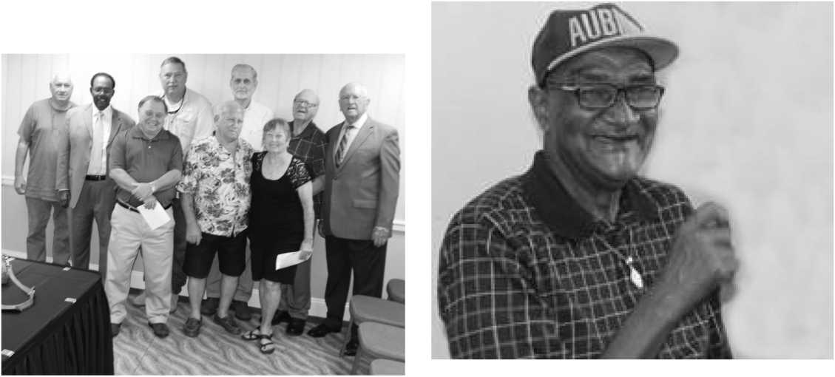

(1) Robert Weaver and Jerry Nelson helped organize the Birming­ham informational meeting and are working with Gerald Buzbee and Danny McGough to start up a Birmingham next year. (2) Ron Shalhoup first member to sign up in Birminham. (3) Pictured above C W Files is responsible to contact and organize CSX and NS retirees in Birmingham area.

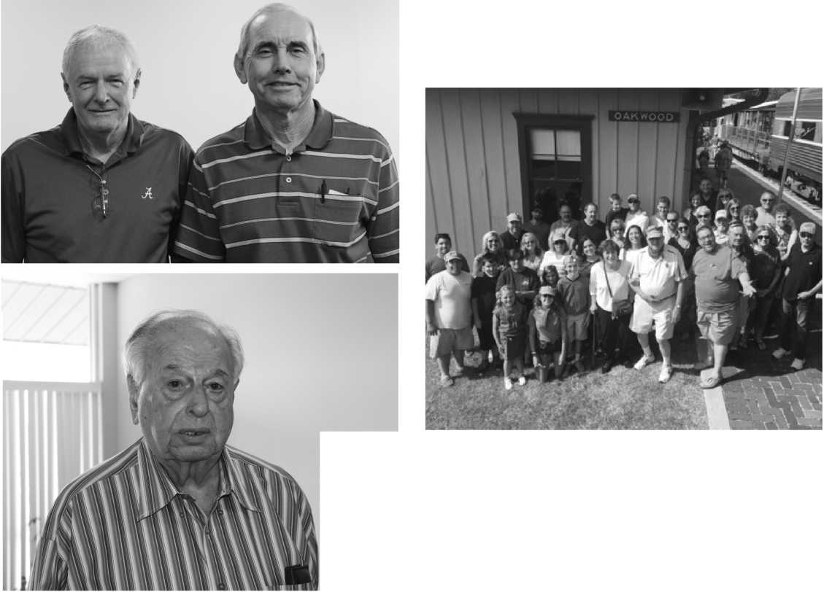

Our thanks, appreciation and praise is in order to a well-connected officer as a former management official in the rail industry. (Former Terminal /Division Trainmaster and Asst. Supt. Administration with BNSF)

Group Picture with Legislative Representative John Higdon's 80th birthday celebration NARVRE El Reno, Oklahoma Unit 145. We had a special birthday party with a railroad theme at the Oklahoma Outdoor Railway Museum which is the old Katy yard. It was so much fun & only family members attending there were 63 & two babies which started in the Party coach & ended with a train ride which for the younger was a big experience. We had such a great time.

—Anthony (Tony) Padilla NARVRE National Vice President

From the National Secretary-Treasurer

S

ummer is over and Fall is here, we had a quick change of seasons this year with cooler weather.

Your National office has been working to get our fall mailings for dues renewal out to all units and Members at large Unit 801 for 2016. Please start notifying your members that their 2016 dues are due by January 1, 2016. The newsletter deadline is February 28, if we have not received the 2016 dues by then the newsletter will be stopped, but it will be reinstated when we receive our members' dues.

We have at this time two new Units 072 of Florence, SC and Unit 026 of Lafayette, LA these units are newly chartered and still growing. This is new territory that has been tapped for potential new units. We have two units organizing in Jasper and Mobile, Al. This is exciting times for building new rela­tionships and growing our NARVRE family.

Taking an excerpt from Whitey Westphal's September article on our NARVRE website, Whitey is Retiree representative from The Moody Law Firm, which is leading many informational meeting throughout this year to gain memberships in our organization. We are pleased to report on activities of units across the nation they have been busy adding new members to our rolls, we have gained 465 new members we want to give credit to the Moody Law Firm and our National Officers and Area Directors and Assistance that have volunteered their time to be involved in informational seminars to work and further enhance our membership with new units and attracting new members.

Area 1 Assistant Director, Phil Steward made the initial contact with prospects in Birmingham, Mobile, and Jasper AL which will be forming new units to be Chartered soon. September has been a busy month with informational seminars being held on Sept 3 at Clinton, IA Unit 067 Railroad Re­tirement benefits and existing laws as they apply to retirees. Sept 15, informational meeting at Denny's Restaurant in Sparks, NV 10:00 AM the Moody Law Firm Retiree and Representative Whitey Westphal and National President Tom Dwyer will be Bob BloomerArea 8Assistant Director and Jackie Kuehl Unit 065 Sacramento/Roseville with Gary Watkins Area 8 Legislative Represen­tative. Discussion of benefits belonging to NARVRE and issues involving Railroad Re­tirement Annuities will be important topics.

Sept 16 Elko , NV at the Oaktree Inn, and

Sept 17 Layton, UT in co-operation with Thomas Babcock Area 8 Assistant Director of Ogden, Ut requested this informational meeting in hopes of starting a unit in Layton.

North Platte, NE Railfest a celebration of Railroad Activities and a booth staffed by Unit 014 headed by Terry Sigler, Legislative Representative. North Platte is in the 3rd Congressional District of Nebraska where the largest concentration of Railroad Retirees reside. There are 10,000 in that district.

Sept 16 Memphis, TN for Unit 018 and on to Cleveland, MS. Sept 12 the Railroad Reunion spearheaded by Bobby R. Henson of Greenville, MS will be held at the Martin and Sue King Railroad Heritage Museum 115 South Bayou Rd, Cleveland, Narvre Officer will address the gathering after the noon meal.

Please invite a Railroader to visit your unit this is a way to grow your membership, ask them to join our organization. These railroaders worked hard for their chance to receive Railroad Retirement, and they can help by joining NARVRE to preserve their future incomes for their retirement years Joyce A. Burton,

National Sec/Treas

Memorandum

I will not be running for reelection of the office of National Secretary-Treasurer for 2016-2018 term. All interested parties contact the National Office.

Thanks,

Joyce

(National Legislative Director from page 1)

major bills. Those problems must be handled by the leadership in the House and Senate if they expect anything to get passed and signed into law.

We will hope that those in Congress will put the economy and the citizens ahead of their own political aspirations, and work together to get the government beyond the threat of another shutdown causing more volatility in the markets adversely affecting retirement trust funds and the retirement values of individual retirees. They signed on to represent their constituents first and we all need to remind them of that responsibility .

It's been slow during these latter months of summer, but it will get interesting moving ahead. Congress will be in session for only 12 days this month before funding runs out... — Gary M. Faley,

Legislative Director

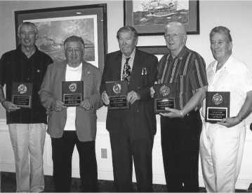

CONGRATULATIONS!

The National Shuffleboard Hall of Fame Recipient for 2015, Carl Howell NARVRE Member of Unit 165 Macon, MO

Carl Retired from Norfolk Southern Rail­road where he was employed as an engineer, In 1996 Carl along with his wife, Carol retired to Mesa, AZ where he took up the sport of Shuffleboard.

Carl and Carol have played in tourna­ments in Arizona, California, Illinois, Iowa; Michigan, Florida, and Missouri. Carl has also competed outside the US in Alberta and Ontario, Canada and also has competed with other countries; Brazil, Australia, and Germany.

Carl has been recognized for his service to further the sport of Shuffleboard. He has given lessons and gone to various parks to help form teams and leagues. This winter Carl will co-chair an evening league of high­ly-skilled players that meet once a week to improve their games

The National Shuffleboard Hall of Fame award is presented to two players wet of the Mississippi and two players east of the Mississippi; they are voted on based on their accomplishments by delegates from twenty + state which have organized shuffleboard. Carl received his award this in July at the semi-annual meeting and banquet which was held in lakeside, OH.

Carl has been captain of several teams and has acquired many trophies on his own. He has held many offices inApache Junction, AZ (District IV) and the Arizona State Shuffle- board Association and was Treasurer of the National Shuffleboard Association.

Carl has also received the President's Award for District IV in 2012 and the State of Arizona Hall of Fame for 2013.

National Shuffleboard Hall of Fame 2015 Recipients pictured left—right:

Chuck Crouse, Arizona; Gus Bondi, Florida; George Atkins, Florida; Stan Quinn, North Carolina; and Carl Howell, Missouri CONGRATULATIONS!!!

NATIONAL ASSOCIATION OF RETIRED AND VETERAN RAILWAY EMPLOYEES, INC. 509 W REED ST Moberly, MO 65270 OCTOBER, 2015

NARVRE NEWSLETTER Volume 29 Number 09

National President Thomas Dwyer 11304 Norway St. NW Coon Rapids MN 55448-3269 763-757-1501 FAX 763-767-5794 [tdwyertcu@aol.com](mailto:tdwyertcu@aol.com)

National Vice President Anthony "Tony" Padilla 303 Black Cap Run Buda, TX 78610-4978 Home: 512-523-8465 Cell: 512-552-8703 [tonypadillatcuiam@austin.rr](mailto:tonypadillatcuiam@austin.rr). com

National Secretary-Treasurer Joyce A. Burton 509 W Reed St Moberly, MO 65270

660-269-8895 [narvre@gmail.com](mailto:narvre@gmail.com)

National Legislative Director Gary M Faley 6324 Calkins Road Flint, MI 48532-3207

810-733-7256 [faleyg@comcast.net](mailto:faleyg@comcast.net)

News deadline 10th of each month Mail to National Office

NON-PROFIT ORG. U.S. POSTAGE PAID KANSAS CITY, KS PERMIT NO. 522

RETURN SERVICE REQUESTED

Railroad Workers and Retirees: You are invited to informational meet­ing Pension benefits under Railroad Retirement Act also membership in NARVRE. Held at Ramada Topes Downtown, 4209 6th Ave.,Topeka, KS, on October 10, 2015 at 10AM. No charge.

B- |

CD CD

<; cc

cd £■"

cr cd

3 ^5

S £

£- CD*

**- s**

5" 2-

cr o

ct) o

?? D CD CL

■8

S. 3

^ , D H

I"

FT ^

O i-s

o  
o  
c

E _

CO 3

CTQ

Ct)

Q 2

p Ei

CO

CO O

3"> S.

O *<!

50

cd 5?

3

CD

o  
o  
Q*

5"

CTQ

3

3 5J

? b;I

fi". CT r*K

8 «S. 5

2 B. 3

CZ2 3  
^ CTQ

- 3

**o**

D

**S**

**a**

**N^\***

0 3 © cl

^T3

**a**

***v>***

n

o a

9

CTQ

=

3

^r

CD 3)

3 § -

r-t 2L «C

°,§:1

td % cr

3 ^ Si

o ?r

£r

CD

o o a- CD

p

© =

***n***

***VI***

©* s

***VI***

•>3

**c**

**Cd** n **=**

m

cr CD

O

0

1

>-t I—4

■a °  
p a-

!«

^ D

o

o

3

e.

B

o

CO rt

< o

rt

**O**

rt-

o

W5

**1?**

« ***3***

& ^

» 5t

fS °

CTQ s"

« z.

•>3 ^r

p

CO

cr  
CD  
CD  
D

O 3

□ o o <D

ct> D O O

c

"-S

P CTQ Ct)

o c

C

O ^

3 ~

***n***

P

s

C/5

CD

3

p ^

o x)

CD ""

**a a**

c^ o

° o

'"S ^

p. O

oT D. CD

c." CTQ

**o**a

***B.***

O c

CL

o o

O I

CD  
P

CO CO

Er

Ct) "O

|-s O

o

cd

o

.f° 2

CD

5. o

D

CO

P  
cr

o

o £  
o o ^

00 o

U> £

CD

o  
o  
a-  
CD

a-  
o

CD

"O  
"-s

O .  
<<  
Cu o

CD G

1. 5 H-t

co 3

3 ^  
p

CO

^ ct)

O CD

8. 3

CD o  
CD

o o  
B.  
3

p5 ^

3 cd

So 3

5' E

o r-°  
o o  
3 3

ft v!

1. o

S I  
^ &

"a g

o 3

2. ^

S- =

Q 3

CO I

CD P

O

5

O CTQ

as o

ft ft

CO CO

m ti;

P  
CTQ

CD 00

o  
e

o

CD 2

co

" "O

O 3  
o N-

" o

2 B>

**'ji** O

« 3

o c

"-t

ti p o CD cr o o

7T T3 P CTQ CD PO

"d

p o

cd

cr

o o

FT

b o 5

3 p 2- ^

CD P CD *<!

***B***

J CD co

53 C5 O ct)

^r p

CD p

o cr

ft

D

CTQ  
O  
£

ct) . "2. : o-"

CD

3

. p

o

D

3

"O

|-s

O C CD

CO

O

O

o

CO

k &

£ 82.

X3 " p

5s 2 £

1-1 o <

2 3 ft

1.3 o'

cu ^ ia

£ 3" 3

a. o g

ia e 2

ft n

CO HJ 1-5

P

O 3. ft

g- &U

p S

< 3 J?

M. 3 O

CO i—> p

^ 00 —

° m °

c £ c

^-s O

£r

CD

CO

p

3

CD

o

S"

3

"O

o  
o  
cd

C-H

o

5" 3

O 3

**O**

o

° R

9 8.

tn

s o **a a-**

**^ o**

CD *

CD "O

***n***

<t

CTQ

O

8

o  
c

CO

O

3

CD

a-

p

CO

cr

c "

|-s CD

C

"O

p

o o

D &

o"

p

H ^r

cr

ft  
ft

***x***

P

"2. o" B

CD

o

rt 9

**5T**

S9

>

Is>

D

£. ^

& "-s

D 3

CTQ

8 B

& i.

'^1

CD

. p  
5" Q-

|  |  |
| --- | --- |
| CO  ^r |  |
| O |  |
|  | CD |
| r-K | X |
| ^r | c |
| P | CD |
|  | CO |
| D | r-t" |
| O | ^r |
| P | P |
| 3  o |  |
| u | CD |
| D | a- |
|  |  |
|  | CJ  p |
| P | "-S |
| CO |  |
| 3 | CD |
| p | O |
| a, -o | |
| CD | CD |
|  | D |
| o | r-t- |
|  | ZT |
| ^r | CD |
| CD | O |
| T3 "-S | P |
| O  <1 | 3 |
| CL CD | o |
| j-s | c |
| p | CD |
| D a- | & |
|  | CD |
| zr  CD | O  o |
| n | |-s |
| p | CD |
|  |  |
| (b |  |
| D | O  o |
|  | a- |
| P* | CD  CO |
| cr |  |
|  |  |
|  | *■< |
|  | o |
| CO | S- |
| -fe/»- |  |
| o |  |
| O | C/3 |
| o |  |

Ho o

£L CD

nr "0

CO I-S

3 o

"T C

P

3-' s*

o

S ft

^ u

S- B-

§ 3

hJ CO

IT CD ^r

co p o

3 ^5; c

—i M CD ^

CTQ

^r

^r

CD

cr CD

o

CL CD

|  |  |
| --- | --- |
| X | O  c |
| CD | D- |
| CD | CD |
| CO | |-s  CO |
| CD | a- |
| 1* | CO |
| P | c |
| q |  |
| "O |  |
| CD | CD |
|  |  |
|  |  |
|  | P |
|  | 3 |
|  | o |
|  |  |
|  | CD |
|  | CO |
|  | "n |
|  | CD |
|  | o |
|  |  |
|  | CJ |
|  | 3 |
|  | CD |
|  |  |
|  | O |
|  | CL |
|  | o |
|  |  |
|  | a- |
|  | p |
|  | (f'Q |
|  | D |
|  | O |
|  | CO |
|  | D |
|  | (10 |
|  | P |

o 00 P TD

GO

ct) o o

3

a-

a­. CD ) CTQ

CTQ

^r

^r

CD

P

co

U) VO

CD p

CD* O

**s a**

T3